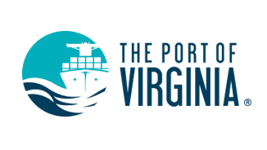Procurement

Virginia Port Authority (VPA) Contracting Opportunities

Important Notice to All Bidders and Offerers
The Virginia Port Authority advertises IFBs and RFPs, and all information pertaining to them (including, but not limited to addenda, bid tabulations and award notices), on the Commonwealth of Virginia’s website known as eVA.
The following link will direct you to the site:
https://www.eva.virginia.gov
After accessing the eVA website, follow these instructions to get to the solicitations:
- Under the Business Opportunities section, click on Virginia Business Opportunities (VBO)
- Under Advanced Search select Virginia Port Authority as the “Buying Entity” then click on the Search button
- The results will show all VPA solicitations in descending order
For information on IFBs and RFPs contact:
proposalsvpa@portofvirginia.com
For general port-related questions:
Phone: (757) 683-8000

